November 14, 2007 Name __________________

CS241 Exam 2

Fall 2007

1. (max = 10) | 6. (max = 20)
2. (max = 8) | 7. (max = 15)
3. (max = 8) | 8. (max = 13)
4. (max = 10) | 9. (max = 4)
5. (max = 12)
Total Score ____________(max=100)

- (10 pts) Use mathematical induction to prove that $\sum_{i=0}^{n}{x^{i}=\frac{x^{n+1}−1}{x−1}}$.

- (8 pts) Write a single recursive method (called astex) that has one parameter which is an int value called n. The method prints n asterisks, followed by n exclamation points. Do not use any loops. Do not use any variables other than n.

public void astex(int n) {

}

- (8 pts) Give an example where dynamic programming can greatly improve the efficiency of a recursive algorithm. Explain how dynamic programming works in this example and why it is more efficient.
- (10 pts total) Linked Lists: Consider the simple Node and LinkedList classes below.
a) (4 pts) Complete the code for the add method which adds a node to the front of the list.
public class Node {
public int value = 0;
public Node next = null;
public Node(int val, Node n) {
value = val;
next = n;
}
}

public class LinkedList {
Node front = null;

public void add(Node n) {
if (front == null) front = n;
else {

}
}
}
b) (6 pts) Add a method called swap to the above LinkedList class which reverses the order of the nodes at position k and k+1. For simplicity, assume that k and k+1 are legitimate indices (i.e. the nodes exist in the list) and assume that k > 0. Drawing a picture really helps!
public void swap(int k) {

}
- (12 pts) Assume c is a constant. Fill in the table with yes or no:
f(n) | g(n) | f = O(g) | f = Θ (g) | f =Ω (g)
log₂ (n!) | log₁₀ (n^{n})
n^{lg(c)} | c^{lg(n)}
100 n³ + n² | (1.01)^{n}
25 n $\sqrt{n}$ | n^{5/2}

- (20 pts total) Fill in the following empty slots in the table below. Assume the list to be sorted is of size n.
Sort Algorithm | AverageTime Complexity | AverageTime Complexity assuming list is already sorted | Average Space Complexity | Divide and conquer (i.e. recursive)(yes/no)
Insertion |  |  | Θ(n)
Bubble | Θ(n²) |  |  | no
Stooge | Θ(n^{2.7})
Merge

Selection

Quick (using left-most element as pivot)

Feel free to add comments below if you want to qualify or explain any of your answers above.

- (15 pts) Suppose you need to apply the operations find(x), insert(x), remove(x) to a list of n data values. Give the worst case Θ complexity of these operations for the following data structures.
 | create(list) | find(x) | insert(x) | remove(x)
unsorted array | Θ(n) | Θ(n) | Θ(1) – adds to end of list
sorted array

unsorted linked list | Θ(n) |  | Θ(1) – adds to front of list
sorted linked list (using sort method used in card hand lab)

balanced binary search tree

Feel free to add comments below if you want to qualify or explain any of your answers above.

- (13 pts total) For the binary search tree below,
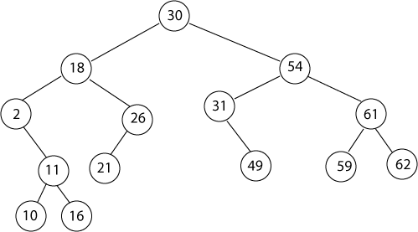
    - (2 pts) Which nodes are the sibling(s) of node 26? ____________________
    - (3 pts) Which nodes are internal? __________________(list them here or circle in above tree)
    - (1 pt) What is the height of the tree? ____________________
    - (3 pts) Which nodes are the descendents of 18?
    - (3 pts) What would be the output of a post-order traversal of the tree?
________________________________________________________
    - (1 pt) if you were to insert the value 36 into the tree, where would it end up (i.e. draw it on the above tree).
- (4 pts) Suppose you do an in-order traversal of the above tree using a recursive method (as in the lab assignment). What will be the largest number of call frames at any instant on the call stack during execution? Assume the traversal is initially called from main(). Explain your answer. It might help to draw a rough picture of the call stack at the instant you are considering.

