Feb 22, 2007 Name __________________

CS241 Exam 1

Spring 2007

1. (max = 10) | 5. (max = 10)
2. (max = 10) | 6. (max = 14)
3. (max = 11) | 7. (max = 10)
4. (max = 10) | 8. (max = 10)
Total Score ________(max=85)

Final grade: ________/ 100

- (10 pts) What does it mean to overload a method? Give an example. Contrast this with what it means to override a method.

- (10 pts total) Suppose you want to create a “triangular” array of cards (called myCards) as shown in the figure below. It has 100 rows. The i-th row contains i+1 cards. Write the code necessary to create this entire array.
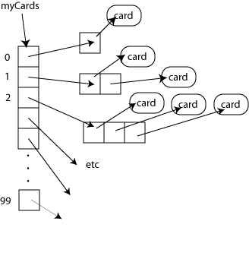
- (11 pts, total) In the previous problem, we drew a diagram showing the references and objects for myCards.
a) (5 pts) Draw a similar type of diagram showing all of the references and objects that would exist after executing the following code (s1 is shown for you).:
String s1 = “cs241”;
String s2 = “stacks”;
String s3 = s1;
String s4 = “stacks”;
String s5 = new String(“stacks”);
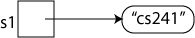
b) (6 pts) What would be the result of the following operations?
b1) s1 == s2 T or F
b2) s1 == s3 T or F
b3) s1.equals(s3) T or F
b4) s2 == s4; T or F
b5) s2 == s5; T or F
b6) s2.equals(s5) T or F
- (10 pts) Describe the difference between a class, an abstract class, and an interface.
How does one create an instance of each?
Can a class/abstract_class/interface inherit from one or more classes/abstract_classes/interfaces? Explain.

- (10 pts) Access Levels
a) (9 pts) Variables declared in a class can have an access level that is package, public, private, or protected. What is the difference between these access levels? Be as specific as possible.
b) (1 pt) If the access level is not specified, what default access level is assigned to the variable?
- (14 pts total) The ArrayQueue class discussed in the text, implements a queue using an array along with the variables front and size.
a. (10 pts) An alternative approach is to use variables front and back, where back points to the next available space in the queue. Complete the following methods below based on this alternative approach. Don’t worry about stretching – assume there are never more than 100 items in the queue at any given time.
public class ArrayQueue<E> {
private E[] data;
private int front;
private int back;

public ArrayQueue() {
data = (E[])(new Object[100]);
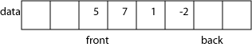

}

public void add(E target) {

}

public boolean isEmpty() {

}

public E remove() {
}
}
b. (2 pts) Suppose one wanted to implement an isFull() method. How do you know when the queue is full?
c. (2 points) Normally, one adds items to the back of a queue. A Deque is a queue that allows you to add items to either the front or the back of a queue. Add a method called addFront to the previous problem that would add an item to the front of the queue.
public void addFront(E target) {

}

- (10 pts) Describe the Java call stack. What does it do and how does it work? What is a call frame and a stack trace?

- (10 pts) Given the Die class:
public class Die {
protected int top=1;

public Die() {}

public int getTop() {
return top;
}
public void roll() {
top = ((int)(Math.random() * 6)) + 1;
}
public void setTop(int t) {
top = t;
}
public String toString() {
return "" + top;
}
}

Below, write a new class called PolyhedralDie that is a subclass of the Die class and which can have any number of sides.

