May 5, 2007 Name __________________

CS 241 Final Exam

Spring 2007

1. (max = 29) | 7. (max = 17)
2. (max = 24) | 8. (max = 15)
3. (max = 10) | 9. (max = 6)
4. (max = 8) | 10. (max = 6)
5. (max = 8) | 11. (max = 8)
6. (max = 10)
Total Score ________(max=141)
Percent:__________

- (29 pts total) Sorting:
  - (5 pts) What does it mean for a sort to be stable?
  - (1 pt each, 24 pts total) Fill in the following table, except for the blocks that have XXXXX's.
Sort Algorithm | Average Complexity | Stable (yes/no) | Sorts in-place (yes/no) | Divide and conquer (yes/no)
Insertion
Selection
Stooge | XXXXX
Merge |  | XXXXX
Heapsort
Quick | XXXXX
Radix | XXXXX

- (4 pts each, 24 points total) Vocabulary: Define each of the following
  - directed graph
  - a polymorphic type
  - LIFO
  - overload a method
  - protected access
  - dynamic programming
- (10 pts total) Loops and Complexity:
Code Segment 1:
int sum = 0;
for (int i=1; i < n; i++) {
sum += i;
}
Code Segment 2:
int sum = 0;
for (int i=1; i < n; i++) {
for (int j=0; j < i; j++) {
sum += 2;
}
  - (4 pts) What is the Θ-complexity of each of the above code segments?
Segment 1:
Segment 2:
  - (6 pts) What is final value of sum expressed as a simple (i.e. not a summation) function of n?

Segment 1:

Segment 2:

- (2 pts each, 8 pts total) For the tree below,
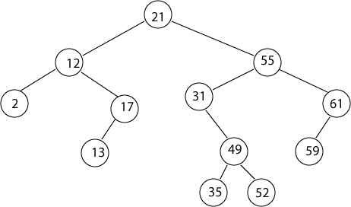
    - Which nodes are the siblings of node 61? ____________________
    - Which nodes are internal? ____________________
    - What is the height of the tree? ____________________
    - What would be the output of a post-order traversal of the tree?
________________________________________________________
- (8 pts) Suppose you have a Node class for a binary search tree with the fields shown below:
public class Node {
public int value;
public Node left, right;
}
Write a recursive method that returns the sum of all the values stored in a node and its decendents. For example, if the method is called on node with value 12 in the tree above, the result would be 44 (= 12 + 2 + 17 + 13)
public int getSum() {
}
- (10 pts) Radix Sort: Suppose you are given the following list of words
cat, tea, bed, cab, bat, add, dad, ate, tab, ebb, act
which are composed from the “alphabet” consisting of the 6 letters: a,b,c,d,e,t
Show the steps radix sort would use to sort these 3 letter words.
- (17 pts total) Graphs:

  - (5 pts) Draw a picture of the adjacency list for the graph below.
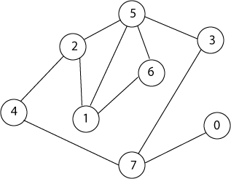
  - (5 pts) Draw a picture of the adjacency matrix for the above graph.

  - (2 pts) In general, what is the space complexity of an adjacency list data structure for a graph with N nodes and E edges?
  - (5 pts) When would you prefer an adjacency list over an adjacency matrix, and vice versa?
- (5 pts each, 15 pts total) Hash functions:
  - What are at least 2 characteristics of a good hash function?
  - Suppose you are creating a word game based on 3 letter words. You want to store all the 3-letter words in the English language in a hash table. Design a good hash function for this problem. Carefully explain why it is a good hash function.
  - Explain why deleting items in a hash table can be problematic.
- (2 pt each, 6 pts total) Heaps: What is the average Θ time complexity of each of the following operations when applied to a heap?
  - build heap: ___________
  - filter down: ___________
  - look at largest: ___________
- (6 pts) Can a tree ever be both a heap and a binary search tree? If so, give an example. If not, explain why not.
- (8 pts) Describe an algorithm which merges k sorted lists into one sorted list and which has time complexity O( n log(k) ), where n is the total number of items in all of the lists combined. (hint: think heap)

