October 21, 2004 Name __________________

CS445 Exam 1

Fall 2004

1. (max = 10) | 5. (max = 13)
2. (max = 25) | 6. (max = 15)
3. (max = 15) | 7. (max = 10)
4. (max = 12) | 8. (Xtra - max = 10)
Final Score ________(max=100 plus 10 Xtra credit)

- (10 pts) Suppose you want to create a snowman made of three spheres of radii 8, 6, and 4. Assume the snowman is sitting on the ground (bottom of lowest sphere is at y=0) at the origin. What sequence of opengl instructions would be needed in the display function to create this snowman? Ignore instructions for the camera and use only the standard transformation commands along with a glutBasicSphere() command that creates a sphere of radius 1 with center at the origin.
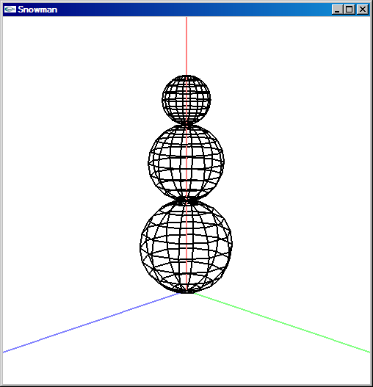

- (5 pts each, 25 pts total) Answer the following. Please use complete sentences. Include a picture if it helps to clarify the written definition.
  - What is a z-buffer and how is it used?
  - What is Gouraud shading and how is it different from Phong shading? What is the advantage/disadvantage of each?

  - What are Hue, Saturation, and Luminance?
  - Describe the difference (qualitatively and mathematically) between an orthogonal and perspective projection?
  - In homogeneous coordinates points are represented as (p_{x},p_{y},p_{z},1) and vectors are represented as (v_{x}, v_{y}, v_{z}, 0). Why are their 4th coordinates different?

- (5 pts each, 15 pts total) 2D Transforms: Write down the 3x3 matrix transform (or sequence of matrix transforms ) needed to perform each of the following transformations. Use homogeneous coordinates. If more than one matrix is needed, make sure the order of multiplication is clear. You do not need to multiply the matrices out. You also do not need to numerically evaluate any trig functions.
  - Scale uniformly by 10. What is the inverse?
  - Rotate by 30 degrees about the point defined by (3,-4). What is the inverse?
  - Scale by 2 along the line through the origin at 20 degrees. What is the inverse?
- (12 pts total) Phong Reflection Model
  - (3 pts) Suppose you are using the Phong Reflection Model to compute the light intensity at a particular point on the surface of an object. If you move your head leaving everything else fixed, what changes at that point? (circle all, if any, that apply)
    - ambient intensity
    - diffuse intensity
    - specular intensity
  - (3 pts) If you move the light source leaving everything else fixed, what changes at that point (circle all, if any, that apply):
    - ambient intensity
    - diffuse intensity
    - specular intensity
  - (6 pts) Describe in words, pictures, and equations, the specular lighting component in the Phong Reflection Model.

- (13 pts) Which operations are legal, well defined operations? If an operation is legal, state what type of variable results (e.g., a point, vector, scalar, matrix, etc). Assume that P_{i} are points, v_{i} are vectors, and α is a scalar in the range 0< α < 1
    - P₁ + v₀ Legal? yes or no. If yes, resulting variable is of type __________
    - α + P₁ Legal? yes or no. If yes, resulting variable is of type __________
    - P₁ - P₂ Legal? yes or no. If yes, resulting variable is of type __________
    - P₁ + α P₂ Legal? yes or no. If yes, resulting variable is of type __________
    - (1-α ) P₁ + α P₂ Legal? yes or no. If yes, resulting variable is of type __________
    - v₁ ₊ v₂ Legal? yes or no. If yes, resulting variable is of type __________
    - α v₁+(1-α ) v₂ Legal? yes or no. If yes, resulting variable is of type __________
    - P₁ v₁ Legal? yes or no. If yes, resulting variable is of type __________
- (15 pts total) More on Geometry.

  - (1 pt) What is the dot product of two unit vectors that point in opposite directions?
Ans = _________
  - (1 pt) What is the dot product of two unit vectors that are perpendicular?
Ans = _________
  - (1 pts) What is the cross product: (1,0,0) x (1,0,0) = _________
  - (1 pts) What is the cross product: (0,1,0) x (1,0,0) = _________
  - (5 pts) Given the points P₀, P₁, and P₂, how do you find the unit normal to the plane that is defined by these points. Include a picture.
  - (3 pts each, 6 pts total) Suppose you are navigating through a scene. P is your current location. The unit vector d points in the direction you are moving, unit vector r points to your right and the unit vector u points up. All three unit vectors are perpendicular to each other. How do you update P, d, r, and u under the following operations:
    - move forward by a distance s.
    - turn to the left by some small amount.
- (10 pts) What are the major stages of the 3D rendering pipeline. What order are they applied?
- (10 pts extra credit) Credit is only given to a perfect or near perfect answer. Given a line defined by the points P₀ and P₁, and a point Q not on the line, how do you find the line that goes through Q and is perpendicular to the line P₀P₁.

