October 28, 2008

CS445 Midterm - Addendum
Fall 2008
Meet Bob. He is an animated character in your next game.
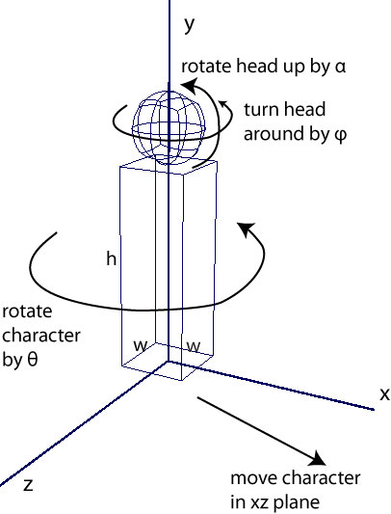
- His torso has height h and a width/depth of w.
- His head sits on top of his torso and has a radius of r.
- He can turn himself by θ and slide about in the xz plane.
- He can rotate (ϕ) his head back and forth (as though saying “no”) .
- He can rotate (α) his head up and down (as though looking up or down). Pivot at bottom.
- Assume he starts out sitting at the origin, looking along the positive x axis.

Draw a scene graph for Bob. Include all transformations that are required to model and control him. Be specific. If you scale (S), translate(T), or rotate (R), you should say by how much and along what axis. Use the syntax:
S(s_{x}, s_{y}, s_{z}), R(angle, axis), T(t_{x}, t_{y}, t_{z})

Use a glut cube as a starting shape for the body. A glut cube is centered at the origin and has sides of length 1.
Use a glut sphere as a starting shape for the head. A glut sphere is centered at the origin and has a radius of 1.

